J505 Divya Dharshini Shankar

SQL-Coding Test  
CRIME MANAGEMENT

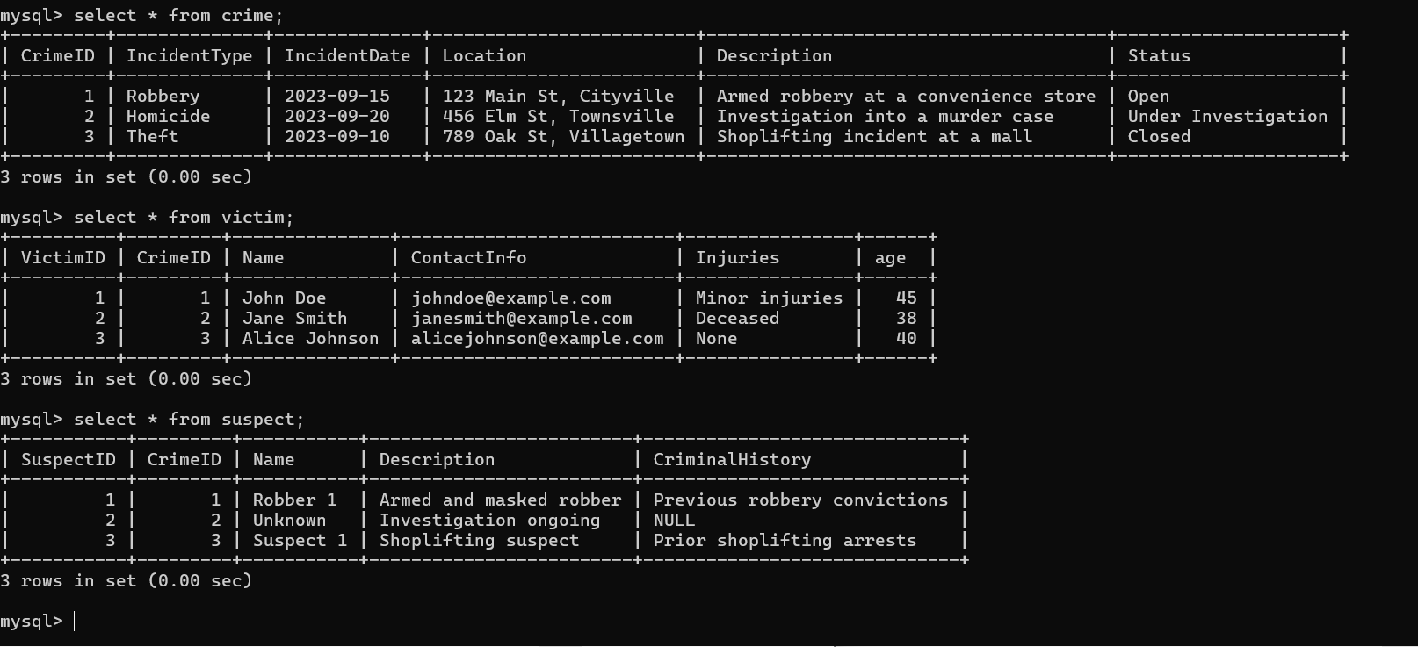

1.Select all open incidents.   
Ans: select * from crime where status = 'open';  
2. Find the total number of incidents.  
Ans: select count(*) as "Total incidents" from crime;

3.List all unique incident types.   
Ans: select distinct incidenttype from crime;

4.Retrieve incidents that occurred between '2023-09-01' and '2023-09-10'.   
Ans: select * from crime where incidentdate between '2023-09-01' and '2023-09-10';  
5. List persons involved in incidents in descending order of age.   
Ans: select name,age from victim order by age desc;  
6. Find the average age of persons involved in incidents.   
Ans: select c.incidenttype,c.crimeid ,avg(v.age) from crime c join victim v on c.crimeid = v.crimeid group by   
c.incidenttype, c.crimeid;  
7.List incident types and their counts, only for open cases.   
Ans: select incidenttype, count(incidenttype) as count from crime where status ='open' group by incidenttype;  
8. Find persons with names containing 'Doe'.   
Ans: select name from victim where name like '%Doe%';  
9.Retrieve the names of persons involved in open cases and closed cases.

Ans: select v.name,c.status from crime c join victim v on c.crimeid = v.crimeid where status in ('open','closed');  
10.List incident types where there are persons aged 30 or 35 involved.   
Ans: select c.incidenttype,v.age from crime c join victim v on c.crimeid=v.crimeid where age =30 or age=35;  
11.Find persons involved in incidents of the same type as 'Robbery'

Ans:select c.crimeid,v.name from crime c join victim v where c.crimeid=v.crimeid and incidenttype='robbery';

12. List incident types with more than one open case.   
select incidenttype, status from crime group by incidenttype, status having count(status)>1 and status='open';

13. List all incidents with suspects whose names also appear as victims in other incidents.   
Ans: select c.incidenttype ,v.name as victim_name,s.name as suspect_name

from crime c join victim v on c.crimeid=v.crimeid

join suspect s on v.crimeid=s.crimeid and s.name = v.name;  
14.Retrieve all incidents along with victim and suspect details.   
Ans: select c.*, v.*, s.* from crime c join victim v on c.crimeid = v.crimeid join suspect s on v.crimeid=s.crimeid;

15.Find incidents where the suspect is older than any victim.   
Ans: select s.name as suspect_name,s.age as suspect_age, v.age as victim_age from suspect s join

victim v on s.crimeid = v.crimeid where s.age>v.age;  
16.Find suspects involved in multiple incidents:   
Ans:select s.name from suspect s join crime c

on c.crimeid =s.crimeid group by s.name

having count(incidenttype)>1 ;  
17.List incidents with no suspects involved.   
Ans:select c.incidenttype from crime c left join suspect s

on c.crimeid=s.crimeid where s.crimeid is null;  
18.List all cases where at least one incident is of type 'Homicide' and all other incidents are of type 'Robbery'.   
Ans: select crimeid from crime group by crimeid

having sum(incidenttype = 'homicide') > 0

and sum(incidenttype != 'homicide' and incidenttype != 'robbery') = 0 and sum(incidenttype = 'robbery') > 0;  
19. Retrieve a list of all incidents and the associated suspects, showing suspects for each incident, or 'No Suspect' if there are none.   
Ans: select c.incidenttype,s.name from crime c left join suspect s on c.crimeid = s.crimeid;  
20. List all suspects who have been involved in incidents with incident types 'Robbery' or 'Assault'   
Ans: select s.name,c.incidenttype from crime c join suspect s on c.crimeid = s.crimeid where c.incidenttype in ('robbery','assault');